Club Columbia
Inspection & Acceptance Checklist
For
N_________

Insert picture of your choice here

This Checklist is provided to the members of Club Columbia as information. Neither the Club nor the author claim that this is complete, correct, or useful for any purpose whatsoever and make no claims of utility, or safety. This Checklist is not the product of an aviation expert. No claims of expertise in any aspect of aircraft maintenance, inspection, ownership or operation are made or implied. . Neither the Club nor the author are responsible for any omissions, inaccuracies, misrepresentations or defects in this document. Use of this document by any individual for any purpose is entirely at their own risk.

Copyright © Club Columbia. All rights reserved.
Except as expressly provided herein, no part of this manual may be reproduced, copied, transmitted, disseminated, downloaded or stored in any storage medium, for any purpose without the express written permission of Club Columbia. Club Columbia members in good standing are granted permission to download this document for their personal use.

TABLE OF CONTENTS

Bring the Following to the Acceptance Inspection…………….….. 1

Interior Inspection……………………………………………………… 3

Exterior Inspection……………………………………………………. 13

Software Inspection…………………………………………………… 19

G1000 Inspection & Set-up…………………………………………... 21

Automatic Flight Control Inspection & Set-up…………………… 23

XM-Digital Audio Inspection………………………………………….29

XM Weather Inspection………………………………………………. 31

EPROX+ (TAWSB) Inspection………………………………………. 33

GTX 33 Mode S Transponder Inspection…………………………... 35

Engine On – On Ground Inspection………………………………… 37

In-Flight Inspection…………………………………………………… 39

Miscellaneous Items…………………………………………………... 41
Aircraft Review………………………………………………………….43

Missing or Defective Items & Notes………………………………... 45

Squawk Sheets ………………………………………………………… 47

Bring the following to the Acceptance Inspection

- Pen
- Portable aviation radio.
- Oil wipe cloth in a plastic bag
- Small tape measure
- Notepad
- Digital Camera
- Tire Pressure Gauge
- Electronic Screen Cleaning Solution
- Empty Spray Bottle and Window Wipes (for cleaning windows on trip back to home base)
- Scotch Guard Carpet Treatment (Pick up at local grocery store - apply after acceptance to make rug cleaning easier)

Interior Inspection (use auxiliary power supply as necessary)

- Obtained two complete sets of keys?
- Record original Hobbs ______________
- Record original Tach ________________
- Go to AUX UTILITY PAGE & Record:
  - Odometer _____________________
  - Trip Odometer _________________
  - Average GS ___________________
  - MAX GS _____________________
  - Flight Timer __________________
- Reset All Trip Statistics
- Airworthiness Certificate on board
- Registration Certificate on board.
- Owners Manual (POH) on board..
- Weight and balance info on board
- Controls Free and Correct (note opposite movement of aileron trim tab)
- Check leather quality on panel and seats. Look for scuffs and muffed repairs.
- Sport Seats Installed
  - Proper color of leather seat covering
  - Proper cushion size on all seats.
- Passenger briefing cards for all passengers
- Laminated emergency procedures provided
- Four Bose Headsets on board.
- Bose Headset connections Pilot, Copilot, Passengers (2)
- Normal headset connections: Pilot, Copilot, Passengers (2)
- O₂ Equipment
  - O₂ cannulas (4)
  - Face mask with microphone (2)
  - Face mask without microphone (2)
- O₂ delivery hardware fits cannulas and masks.
- O₂ system flows and delivers O2 at adjustable rates
- O₂ system leak check: Take readings as far apart in time as practical.
  - Pressure _______ psi Temp _________ C at _________ am pm
  - Pressure _______ psi Temp _________ C at __________am pm
  - P/T should be approximately the same for each of the above. If not suspect a leak.
- Fuel Valve generates a WARNING alert if OFF or not properly seated in a LEFT or RIGHT detent.
- Wing flaps operational and movement as indicated by switch setting.
- Light bar on flap knob flashes when flaps are in motion.
- Check flood light cut into glare shield for “clean” install.
- Check for proper trim around ELT switch and repair of old switch position.
- Lights – Test the following

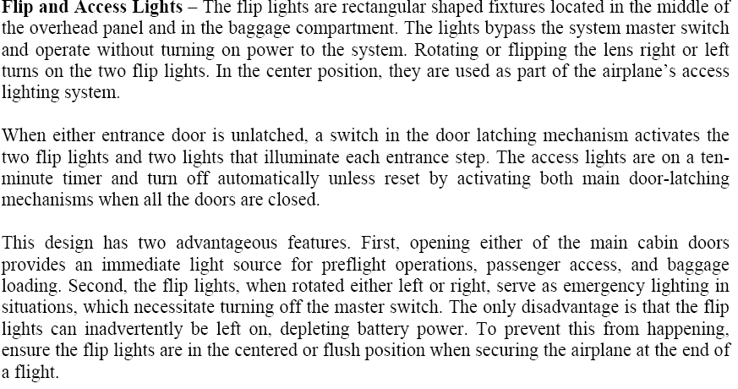
  - Flip and Access Lights
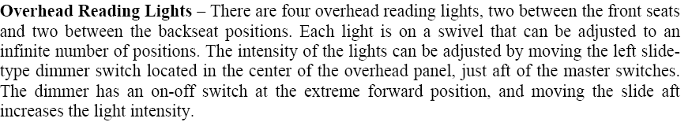
  - Overhead Reading Lights
  - Instrument Flood Bar
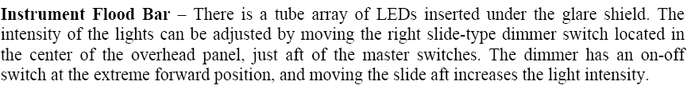
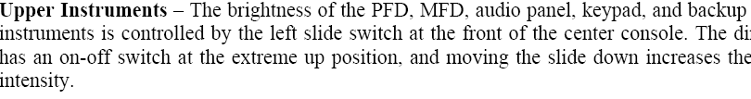
  - Upper Instruments
  - Lower Instruments, Circuit Breaker and Master Switches Panels.
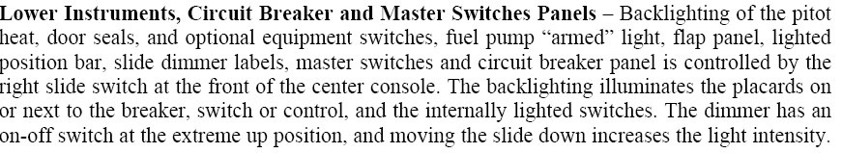

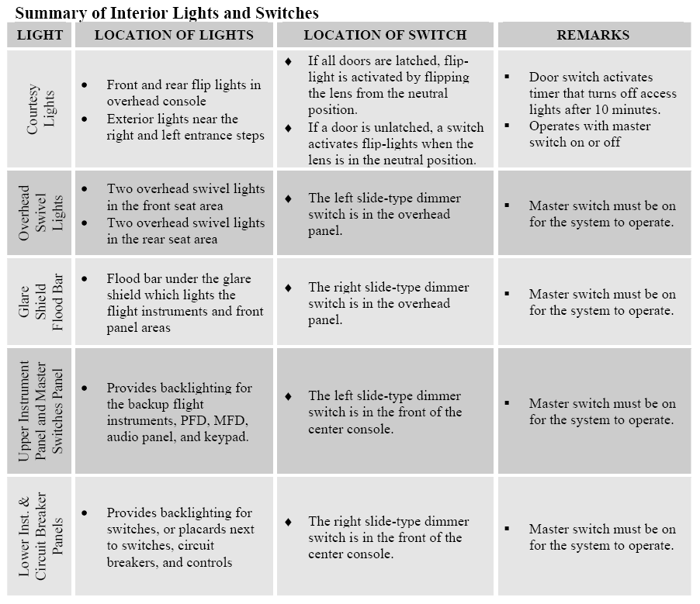

- Press to Test Button Illuminates the following:
  - All indicators associated with the flaps panel
  - Pitot heat
  - Door seals
  - Optional equipment switches
  - The lights are brightest when the Position lights are OFF
  - The lights are dimmest when the Position Lights are ON
- Front seats move approximately 7” fore and aft.
- Seat Belts and Harnesses for all occupants are attached solidly and webbing is continuous.
- Seat belts and harness buckles operate properly.
- Doors open and close easily and are supported in the fully open position.
- Each door has a strap and snap in storage of strap.
- Door open annunciated on PFD for:
  - Open pilot side door.
  - Open copilot side door.
  - Open baggage door.
- Baggage door.
  - Has two locks; front lock will not allow the key to be removed when the door is open and unlatched/unlocked.
  - Both locks operate smoothly with all keys.
- Door locks and latches on pilot and copilot doors operate properly.
  - Pilot door has externally operated lock.
  - Copilot door has an internally actuated lock.
  - Pilot door lock works smoothly with all keys.
- Test door seal operation
  - Seal inflates when doors are closed and latched
  - Door seal pump stops after inflating door seal.
  - Seal deflates when door latching mechanism is moved more than a half inch towards the open position.
- Check operation of throttle, propeller & mixture controls.
  - Control moves smoothly
  - Check friction adjustment if available.
  - Check vernier operation
- ELT Test – NOTE CAN OLY PERFORM THIS DURING THE FIRST 5 MIN OF ANY HOUR!
  - Tune hand held radio and aircraft radios to 121.5.
  - Turn dashboard remote ELT switch ON.
  - Verify that the red light on switch flashes and a beep is heard on 121.5
  - Limit test to three flashes/beeps
  - Reset switch to ARM & verify beeping stops.
- Compass swing card error filled in.
- Fire extinguisher present and in good condition
- Safety Axe present and properly seated.
- Tow Bar present and locked down
- Baggage tie downs and restraining net present
- Fuel sampler cup present
- Speed brakes installed and operational
  - MFD Annunciator page indicates Up when deployed properly.
- Installed Equipment – Check POH vs Presence
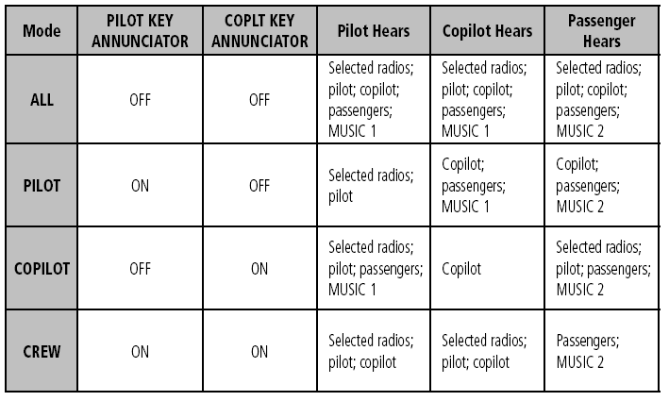
- Intercom operates according to the following table:

- Audio Pannel check – Tune Com 1 to Unicom/ATIS Com 2 to ATIS/Unicom
  - Press Com1 And request Radio Check 1 Should send and receive on Com 1
  - Press Mike 1 and request Radio Check 2. Should send and receive on Com1
  - Flip Com2
  - Press Mike 2 and request Radio Check 3. Should send and receive on Com 2
  - Flip Com2 and tune all Unicom to unused or remote channel.
  - Press Com1 then Mike 2 – should hear ATIS but show TX on Com2
  - Flip Com1 & Com2
  - Press Com 2 then Mike 1 – should hear ATIS but show TX on Com 1
- Press com 1/2 and make sure both are on unused channels
  - Push Pilot PTT – should TX on Com1 and Com1 blinks
  - Push Copilot PTT – should TX on Com2 and Com2 blinks
- Test speaker by pushing SPKR button and hearing ATIS over speaker.
- Test PA by pressing PA and talking. Should come over speaker.
- Test Digital Clearance Recorder by
  - Pressing play and getting playback of most recent RX. Press twice for second most recent.
  - Press MKR/MUTE during playback to terminate play back early.
- The following interior placards must be in place:
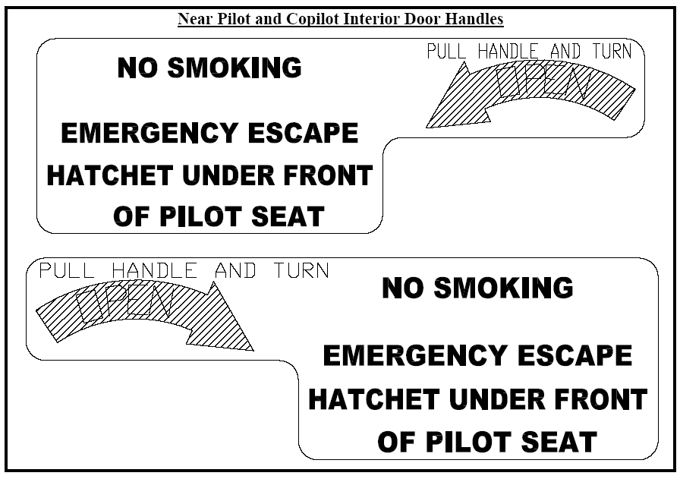
- Interior Placards Cont’d:
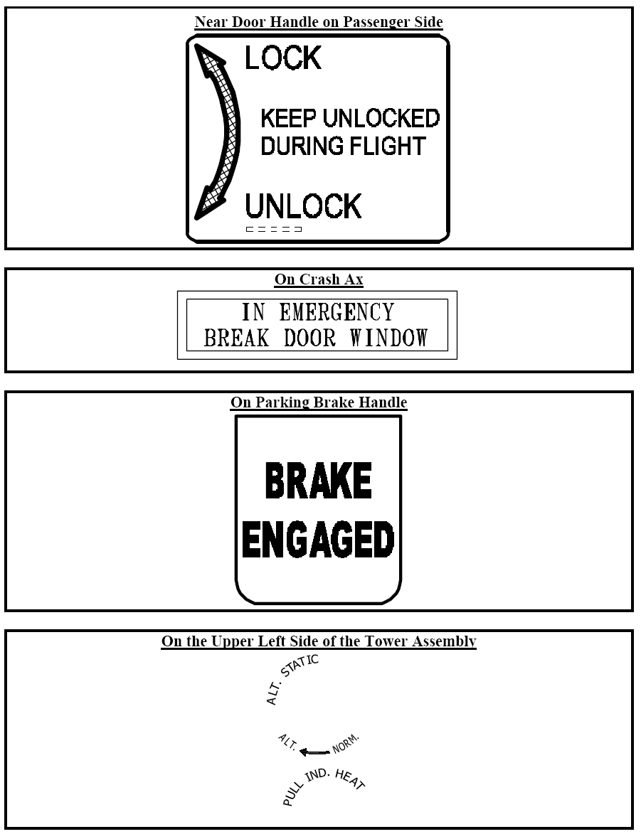
- Interior Placards Cont’d:
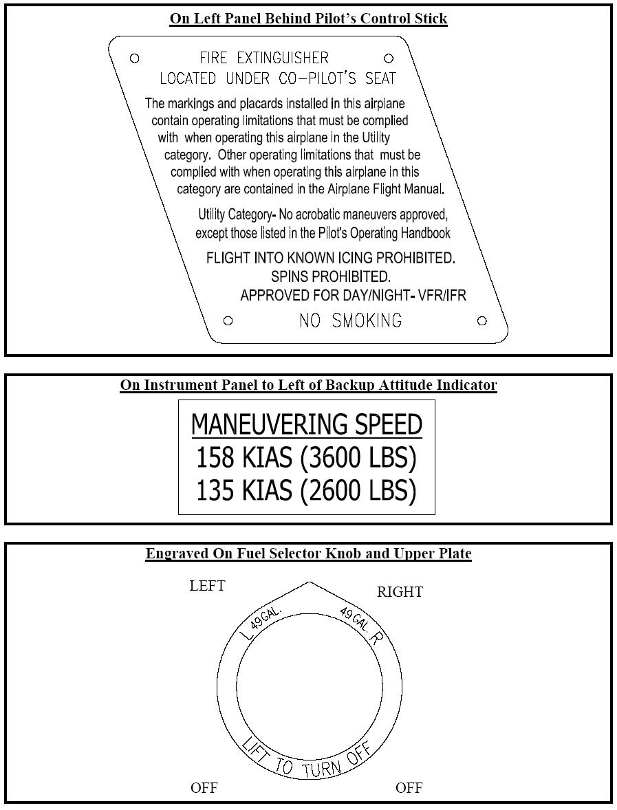
- Interior Placards Cont’d:
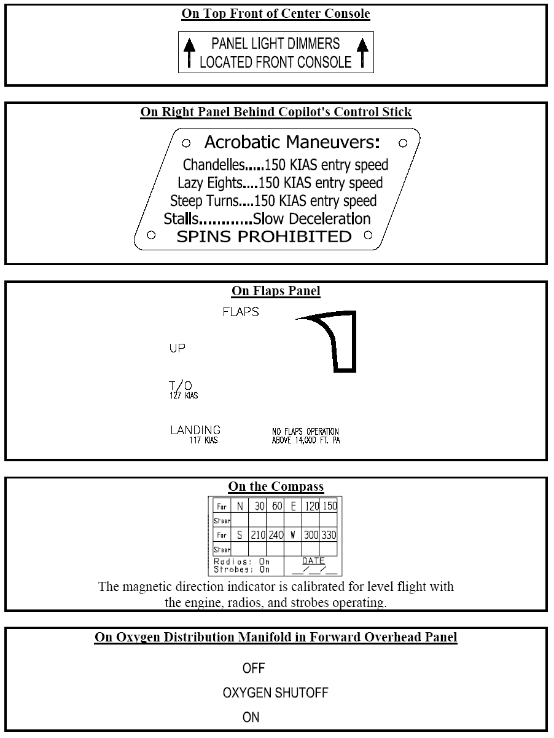
- Interior Placards Cont’d:
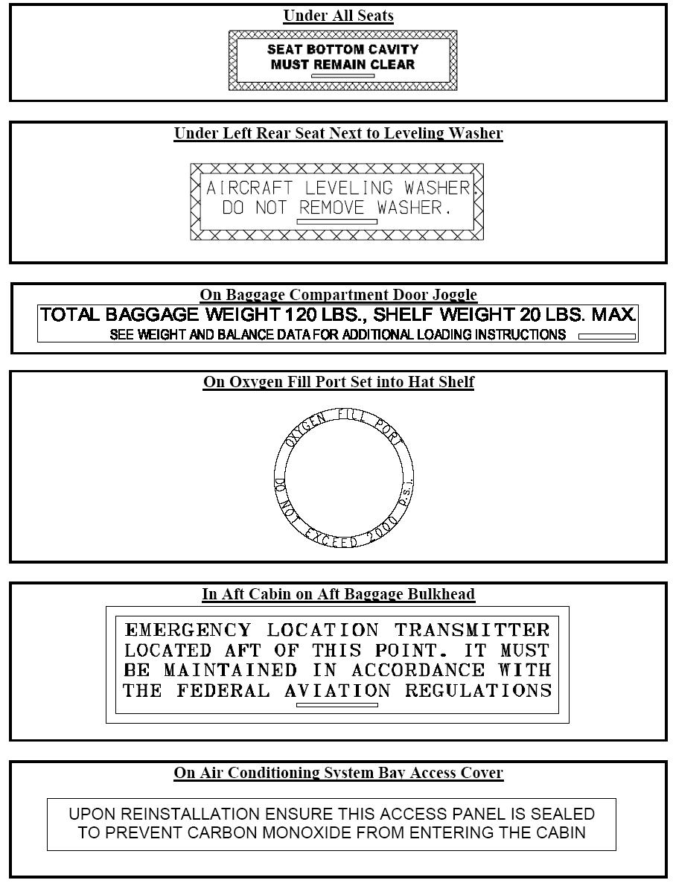

Exterior Inspection

- Color is ____________ Belly, __________ stripe and ________ pin stripe.
- N number ___________________ is correct and applied with shadow.
- All leading edge devices (stall strips, leading edge tape, flat triangular leading edge tape, and zig-zag tape) must be installed and in good condition for flight.
- Check general quality of paint (pay close attention to pin striping) on:
  - Fuselage
  - Left wing
  - Left landing gear
  - Front landing gear
  - Right wing
  - Right landing gear
  - Right stabilizer
  - Rudder
  - Left stabilizer
- Check Left, Right & Front wheel fairings for proper attachment
- Non slip tape on each wing by door.
- Rudder Hinges NOT Rusting
- Wing Anti-Ice system installed.
- Hot prop installed and operational.
- Pitot heat operational.
- Test Position Lights.
- Test Anticollision/Strobe Lights.
- Test Taxi and Landing Lights..
- Xenon Landing light installed
- Tire Pressure Set Properly
  - Nose Tire 88 psi
  - Main Gear Tires 55 psi
  - Nose Strut ______” chrome showing (3”-4” acceptable range)
- Doors fit to fuselage properly.
- No visible cracks around window on either door.
- Handles and step by flap installed both sides.
- Static Wicks
  - Two on left wing
  - Two on right wing
  - Five on Tail
- Open and inspect Oil Access door for fit and finish.
- Oil level _________ quarts (6-8 acceptable,)
- Remove top portion of Cowling
  - Platinum Engine Installed
  - Inspect engine for any oil leaks.
  - Look inside of cowling.
  - Check bottom inside of cowling for signs of oil leaks
  - Check oil filter area
    - Check belts for tightness
    - Check that all hoses are securely attached.
    - Check bottom cowling for signs of oil residue/leaks.
    - Check exhaust manifolds for signs of leaks
  - Take pictures of inside engine compartment.
- Check baffling for proper sealing.
- Check that the latest baffling SB is complied with
- Check that serial number on Pilots Operating Handbook and FAA Approved Flight Manual matches that on the Fuselage Identification Plate. FIP is located on the tail cone as is Type Certificate, year of manufacture, and Production Certification number.
- Antennas in place
  - GPS (2)
  - Marker Beacon
  - Comm1
  - Comm2
  - NAV
  - Transponder
  - TCAD top and bottom
  - XM
- Check that all drain holes on underside of aircraft are open.
- Check that all current SB’s are complied with.
- Exterior Placards:
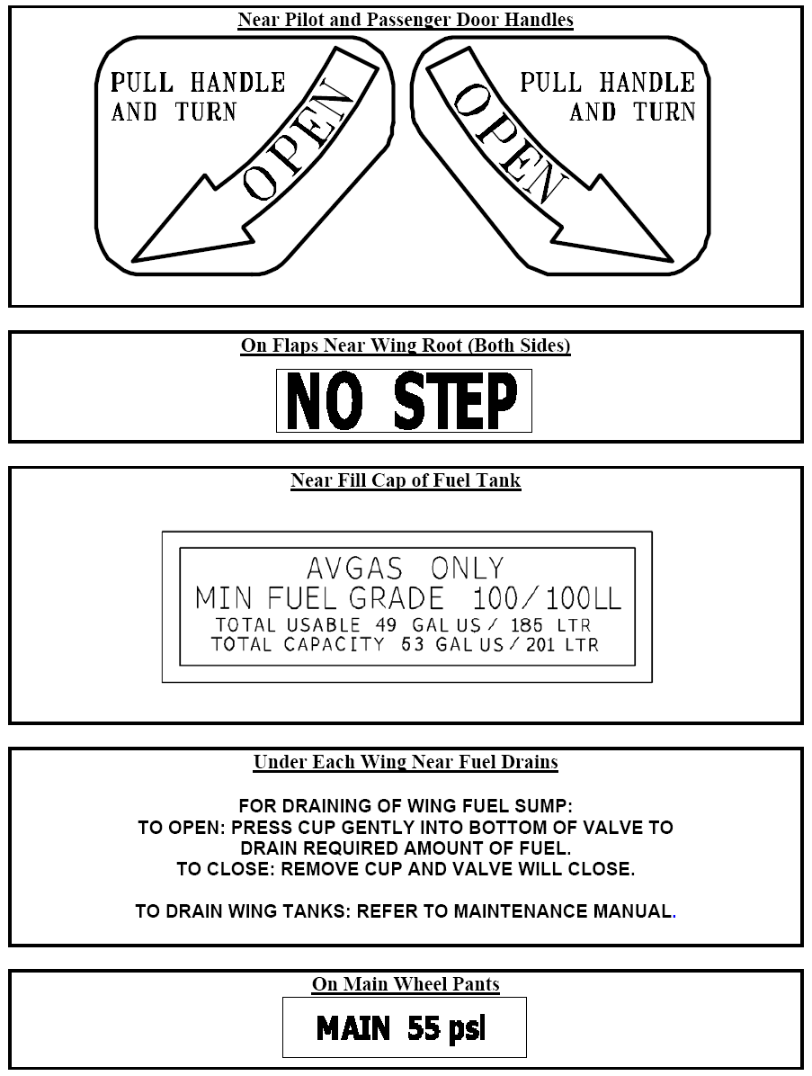
- Exterior Placards Cont’d:
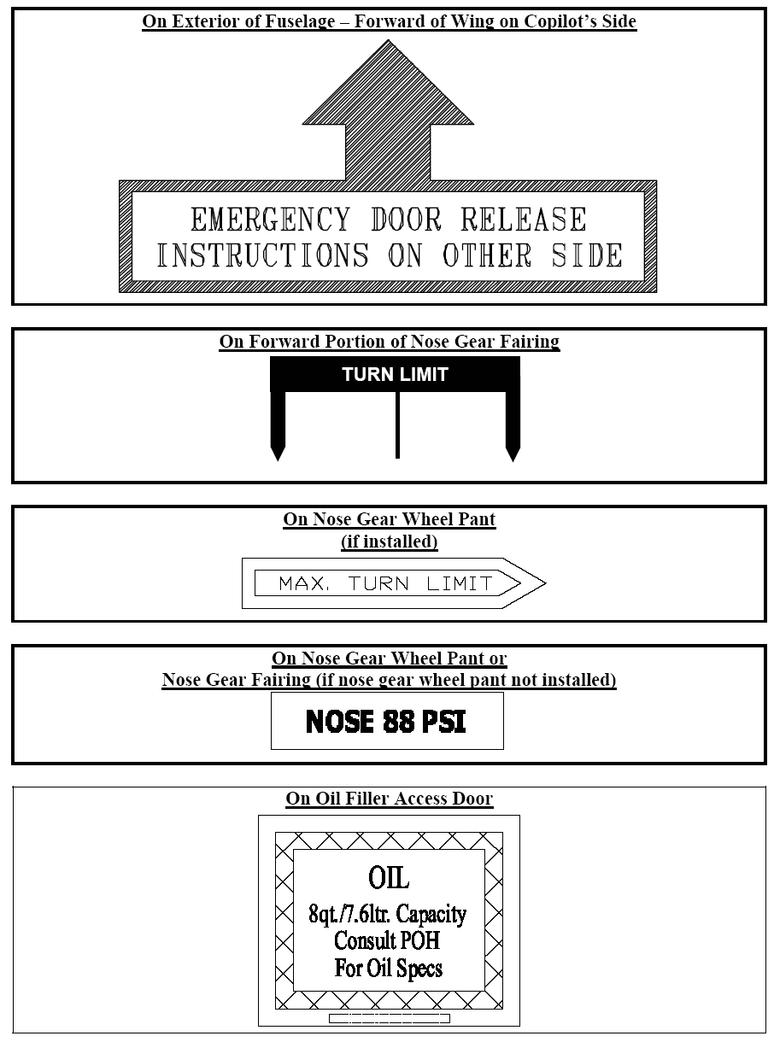
- Exterior Placards Cont’d:
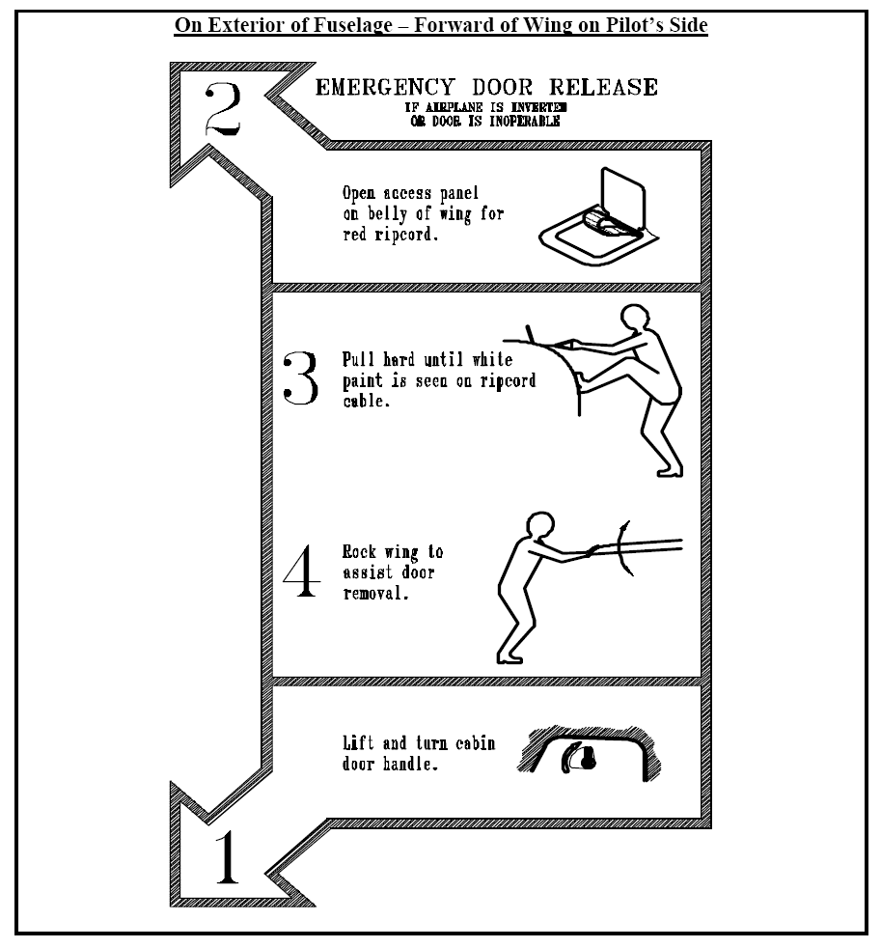
- Exterior Placards Cont’d:
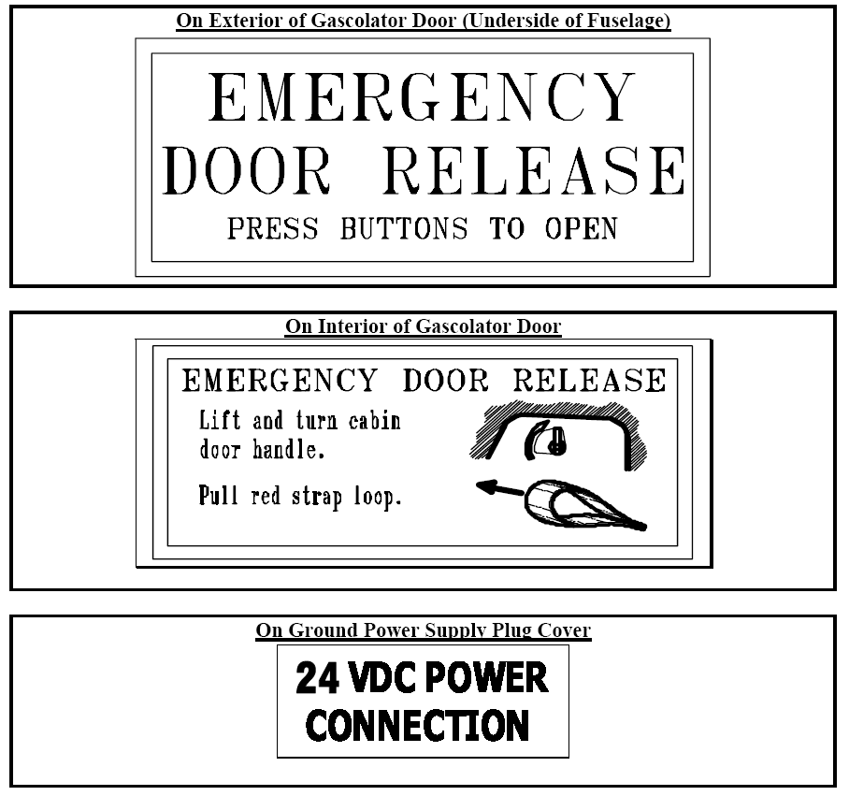
Software Inspection

- The following Software is installed
        - G1000 Database
        - EPROX +
        - Sat WX
        - GARMIN XM Software Update Installed
        - Sat Radio
        - E-Plates
        - T-Watch Traffic Advisory Software (if required)

G1000 Inspection & Set-up

- Cockpit Reference Guide in Cockpit
- SD cards (2 – One each PFD & MFD) installed.
- Turn on Master Switch.
  - Key annunciator lights become momentarily illuminated on the Audio Panel, MFD, and the display bezels.
- PFD
  - Test annunciators appear on PFD initially indicating INOP
  - ALL annunciations disappear within the first minute of power-up
  - AHRS displays “AHRS ALIGN: Keep Wings Level”
  - Valid attitude and heading fields appear within the first minute
  - Heading Indicator agrees with compass.
- MFD Displays the following
  - System version – Latest Version
  - Copyright
  - Land database name and version
  - Obstacle Database name and version
  - Terrain Database name and version
  - Aviation Database name, version, and effective dates
    - Current date is within effective date range
- View AUX page 4.
  - If not previously defined, the following default settings must be made in the “SYSTEM SETUP” menu of the G1000 prior to operation.
    - DIS.SPD kt (sets navigation units to “nautical miles” and “knots”)
    - ALT.VS ft fpm (sets altitude units to “feet” and “feet per minute”)
    - POSITION deg-min (sets navigation grid units to decimal minutes): HDDD”MM.MM”dd.mm.ss
    - MAP DATUM WGS 84 (sets map datum to WGS-84)
  - Move into the MFD Data Bar Fields and set the readouts to be:
    - GS – Ground Speed
    - DIS – Distance to next waypoint
    - ETE – Estimated time Enroute to the next waypoint
    - ETA – Estimated Time of Arrival at the Destination
- View the AUX page 5 (System Status) to verify all LRU’s are operational. Report any failed LRU’s for service.
  - E-plates software installed and operational.
  - T-Watch system installed and operational
- Press Display backup to test that the MFD goes into reversionary mode.
- Fuel Switch operates properly and annunciators on GPS MFD synchronized with valve position.
- Perform Manual TAWS system test
  - Display TAWS page
  - Turn the small FMS knob to select “Test Taws”.
  - Press the ENT Key. TAWS TEST is displayed in the center of the page and an aural TAWS System Test, OK is heard.
- Go to Aux Page 3 and check status of each GPS unit.
  - Press GPS1 softkey and confirm GPS solution is 3D NAV
  - Press GPS2 softkey and confirm GPS solution is 3D NAV
- Map Set-up:
  - Press and hold the CLR (DFLT MAP) key until Map Page appears.
  - Press Menu Key, select Map Setup and press enter.
  - Make the following selections:
    - Orientation – HDG UP
    - Land Data – ON
    - Track Vector – ON
    - Wind Vector – ON
    - Nav Range Ring – ON
- XM Radio receives stations.
- XM Weather displays properly
- E-plates are installed and operational

Automatic Flight Control System Inspection & Set-up

- Preflight test the GFC 700 for proper operation.
  - Turn on A/P Trim system switch on Overhead Console.
  - System performs preflight system test, sounds aural alert at completion and displays a black and white PFT in the AFCS Status Field.
  - Check for proper operation of A/P Trim System Switch on stick.
    - Aileron trim hat switch operates on both pilot and co-pilot sticks.
    - Elevator trim hat switch operates on both pilot and co-pilot sticks.
    - Trim position displayed properly on the Engine Information Systems (EIS) left side of MFD
    - Press Engine Soft Key. Trim position displayed properly on the Engine Page.
  - Turn on AP.
  - Apply forward pressure on control stick
    - Trim should run NOSE UP after 3 seconds
  - Apply AFT pressure on control stick
    - Trim should run NOSE DOWN after 3 seconds
  - AP should turn off if:
    - The AP DISC button on the pilot or co-pilot stick is pushed.
    - The Go Around button is pushed
    - AP key on the MFD is pushed
- In-flight Tests of the Flight Director Pitch Mode (PIT) and Roll Hold Mode (Roll)
  - During a climb press the FD key to activate the Flight Director.
    - Flight director should appear and indicate a GREEN Pitch Hold (PIT) and a GREEN Roll Hold (ROLL) in the PFD AFCS Status Box.
    - The ALT indicator should appear in WHITE indicating Altitude Capture is armed.
    - Should be able to set new pitch using the Nose UP/Nose Down keys
    - Should be able to set new pitch by using CWS button
    - FD should command a level off at the Selected Altitude and transition to the ALT mode. The ALT indication should turn GREEN and the Altitude Reference should indicate the Selected Altitude.
  - Test Roll Hold limits
    - Use CWS to create a bank angle of < 6 degrees.
    - FD should move to roll level
  - Use CWS to create a bank angle of 6 to 22 degrees.
    - FD should maintain aircraft roll attitude
  - Use CWS to create a bank angle > than 22 degrees.
    - FD should limit bank to 22 degrees.
- In-flight tests of the Flight Director Altitude Hold Mode (ALT)
  - Press the FD & ALT keys to activate the Flight Director ALT mode
    - A GREEN ALT and FD Altitude Reference appear in the PFD AFCS Status Box.
  - Fly to a new altitude reference using the CWS button.
    - The Altitude Reference should change to the new altitude
  - Using the ALT knob set a Selected Altitude 300’ – 500’ above the current altitude.
  - Activate ALT mode
    - GREEN indications should appear on the PFD as above.
    - Use the CWS button and capture that Altitude
    - The Altitude Reference should NOT change unless the CWS button is pushed again after the Selected Altitude is captured.
- In-flight tests of the Flight Director Vertical Speed Mode (VS)
  - Using the ALT knob set a Selected Altitude 1000’ above the current altitude.
  - Start a 500 fpm full power climb
  - Press the VS key.
    - PFD AFCS Status Box should show a GREEN VS with a 500 fpm reference speed. and a WHITE ALT (indicating armed alt capture)
  - Change and hold a new reference speed using the CWS key.
    - Reference speed should change to and agree with vertical speed at the time the CWS key was released.
    - FD should command a level off at the Selected Altitude and transition to the ALT mode.
    - The ALT indication should turn GREEN and the Altitude Reference should indicate the Selected Altitude
- In-flight tests of the flight Director Flight Level Change Mode (FLC).
  - Using the ALT knob set a Selected Altitude 1000’ above the current altitude.
  - Set up a full power climb at 110 knots.
  - Press the FLC key.
    - AFCS Status Box shows FLC and Airspeed Reference in Green and a WHITE ALT (indicating armed alt capture)
  - Change to a 130 knot climb using the CWS Key.
    - Airspeed Reference should indicate 130 knots
  - Change to 140 knot climb using the Nose UP/Nose DN keys
    - Airspeed Reference should indicate 140 knots
    - FD should command a level off at the Selected Altitude and transition to the ALT mode.
    - The ALT indication should turn GREEN and the Altitude Reference should indicate the Selected Altitude.
- In-flight tests of the Go Around Mode (GA)
  - Push the Go Around Switch located on the Flap Panel
    - The AP is disengaged (if engaged)
    - The AFCS indicates GA in GREEN in both the Roll and Pitch mode fields of the AFCS.
    - The altitude Hold Mode is automatically armed and ALT is displayed in WHITE in the AFCS.
    - The FD directs wings level, 7 degree pitch-up attitude.
    - Modifying the attitude with the CWS or Nose Up/DN keys results in reversion to Pitch and Roll Hold Modes
- In-flight tests of the FD Heading Select Mode (HDG)
  - Set a course for zero degrees.
  - Press the HDG knob to synchronize the elected heading to the current heading.
  - Press the FD and HDG keys
    - HDG appears in GREEN on the Roll portion of the AFCS.
    - Pressing CWS, changing heading and releasing CWS causes FD to give guidance back to selected Heading.
  - FOR THE REMAINDER OF THE TESTS STAY ON A 0 DEGREE HEADING AND NOTE THAT THE RESPONSES ARE CORRECT
  - Turn HDG knob LEFT to 270 degrees
    - 270 is indicated in the Selected Heading Box (which disappears after a short while)
    - Heading Bug moves to 270 degrees.
    - FD directs a LEFT turn to 270 degrees.
  - Turn HDG knob RIGHT to 90 degrees.
    - 90 is indicated in the Selected Heading Box
    - Heading Bug moves to 90 degrees.
    - FD directs a RIGHT turn to 90 degrees.
  - Turn HDG knob RIGHT to 270 degrees.
    - 270 is indicated in the Selected Heading Box
    - Heading Bug moves to 270 degrees.
    - FD directs a RIGHT turn to 270 degrees.
  - From a heading of zero degrees turn HDG knob RIGHT 341 degrees.
    - FD directs a LEFT turn to 341.
- In-flight test of the Navigation Mode (GPS,VOR,BC)
  - Set Selected Altitude to current altitude + 300’
  - Select GPS on the CDI
    - Set the GPS direct to any area in which a safe cruise can be made for 10 min.
    - Set the Course to the DTK using the CRS knob
    - Press AP and then NAV
      - GPS appears in GREEN in the AFCS Roll section
      - ALT appears in WHITE in the AFCS Pitch section
      - FD directs turn to CRS and climb to altitude
      - ALT arms upon intercepting correct altitude
  - Tune a local VOR radial that can be followed safely for 10 min.
  - Set Selected Altitude to current altitude + 300’
  - Select VOR on the CDI
    - Using the CRS knob center the VOR
    - Press AP and NAV
      - VOR appears in GREEN in the AFCS Roll Section
      - ALT appears in WHITE in the AFCS Pitch Section
      - FD directs turn to CRS and climb to altitude
      - ALT arms upon intercepting correct altitude
- In-Flight test of the Approach Mode (GPS, VAPP,LOC) Mode
  - This test is done for each of: GPS, VOR Approach (VAPP) and Localizer
  - Line up 1.5 dots to one side of the final approach to a GPS, VAPP, or Localizer.
  - Set the CDI to the Navigation aid being tested
  - Set the CRS to the inbound heading
  - Set the Desired Altitude to 200’ below the current altitude.
  - Push FD & then APR
    - The approach navigation aid is armed (in WHITE) and ROL (GREEN) mode is active in the Roll section of the AFCS
    - Altitude mode is armed (in WHITE) and PIT (GREEN) mode is active in the Pitch section of the AFCS
    - The FD indicates a descent to capture the Desired Altitude and a join of the approach airway.
    - Upon capturing altitude and airway the Approach Mode and ALT Mode are indicated as active (GREEN)
    - Glideslope Mode is automatically armed when LOC Approach Mode is Selected. It becomes active upon interception of the Glide Slope.
- In- flight test of the Auto Pilot
  - Autopilot testing is preformed by repeating the FD testing with AP substituting for the AD. The following differences should be noted:
    - Pressing AP provides a GREEN AP Engaged designation in the AFCS
    - Whenever CWS is used a WHITE CWS is displayed in the AFCS box.
    - The AP servos can be manually over-ridden in case of emergency.
    - AP manually disengages when :
      - Pushing the AP DISC Switch.
      - Pushing the Go Around Switch.
      - Pushing the AP Key on the MFD
    - Manual disengagement is indicated by a five-second flashing yellow AP annunciation and a two-second autopilot disconnect aural alert.
    - Pressing the AP DISC or the MET Switch cancels the aural alert.

XM Digital Audio Inspection

- Inspect AUX 5 – XM Information page for existence of all products and activation of the system
    - AIRMET
    - CITY
    - CLD TOP
    - COUNTY
    - CYCLONE
    - ECHO TOP
    - FRZ LVL
    - LTNG
    - METAR
    - NEXRAD
    - RADAR CVRG
    - SCIT
    - SIGMET
    - SFC
    - TAF
    - TFR
    - WIND
- Review proper operation of the Radio page:
  - Changing Channels
    - Using CH+ and CH-
    - Using the DIR CH key
  - Changing/Selecting Categories
  - Changing Volume
    - Using soft keys
    - Using small FMS knob
  - Test select a PRESET
- Radio is heard in all four headsets

XM Weather Inspection

- Go to MAP, Weather Data Link, and test that each work:
  - NEXRAD
  - Graphical METAR Data
  - Textual METAR Data
  - Textual Terminal Aerodrome Forecasts (TAF)
  - City Forecast Data
  - Graphical Wind Data (WIND)
  - Graphical Echo Tops (ECHO TOP)
  - Graphical Cloud Tops (CLD TOP)
  - Graphical Lightning Strikes (XM LTNG)
  - Graphical Storm Cell Movement (CELL MOV)
  - SIGMET/AIRMETs (SIG/AIR)
  - Surface Analysis including City Forecasts (SFC)
  - Freezing Levels (FRZ LVL)
  - Hurricane Track (CYCLONE)
  - Temporary Flight Restrictions (TFR)
  - Legend
- Check for display of a Map and Weather data on the following MFD pages
  - Navigation Map Page (NEXRAD and XM Lightning only)
  - Nearest Pages (NEXRAD and XM Lightning only)
  - Weather Information Page – part of the Waypoint Airport Information Page (METAR and TAF info only)
  - Flight Planning Maps (NEXRAD and XM Lightning only)
  - AUX – Trip Planning Map (NEXRAD and XM Lightning only)
- Check for display of Weather data on the PDF Inset Map
  - Topography
  - Terrain
  - NEXRAD
  - XM Lightning

EPROX+ (TAWSB) Inspection

- On power up “TAWS System Test, OK” aural report is given.
- On TAWS Map page press MENU key and select TAWS Test.
  - Upon completion of test “TAWS System Test, OK” aural report is given.
- On TAWS Map page press MENU key and select Inhibit TAWS
  - A “TAWS INHB” message is displayed on the TAWS map page.
  - Reactivate TAWS.

GTX 33 MODE S Transponder

- When on the ground a GREEN GND indication and transponder code appear in the mode field of the Transponder Data Box.
- Push the STBY Softkey
  - A WHITE STBY indication and transponder code appear in the mode field
- Press ON Softkey
  - A GREEN ON indication and transponder code appear in the mode field
- Press ALT Softkey
  - A GREEN ALT indication and transponder code appear in the mode field.
- Set the transponder code to 4321 then press the XPDR Softkey then the VFR Softkey.
  - 1200 appears in the Transponder Data Box
- Press VFR again
  - The original code (4321) appears in the Transponder Code Box.
- Press the IDENT Softkey
  - A Green IDENT indication is displayed for 18 sec.
  - If the display is in ANY lower level the system reverts to the top-level softkeys.

Engine On – On Ground Inspections

- Manifold pressure Proper Reading
  - Engine Off – Atmospheric Pressure (not corrected for sea level)
- Oil Pressure
  - 10 psi or greater at idle
- On Ground Baseline Electrical Readings
  - Left Alt ____________________
  - Right Alt __________________
  - Battery Amp Left _______________
  - Battery Amp Right _______________
  - Bus Volts Left _________________
  - Bus Volts Right ________________
- Idle approx 800 rpm
- Test parking brake operation
  - Press on brakes and set parking brake – Should hold brakes.
  - Rev engine slightly to assure hold
- Aural warning occurs when engine RPM exceeds 1800 rpm and either door is open. (WARNING!! Keep doors firmly in grasp or may be damaged!)
- Automatic Climate Control System
  - Check fan speed
  - Check OAT display
  - Check manual mode
  - Check auto mode
  - Check defroster operation
  - Check temperature control
  - Check compressor ON\OFF function button
- Taxi Inspection
  - Brakes operate properly
  - Brake steering operates properly
  - Front wheel does not shimmy when taxiing
  - Attitude indicator does not precess
  - Turn and bank indicator indicates properly

In Flight Inspections

- Manifold Pressure Operating Range.
  - Full Throttle ________ “ (nominally 35.5”).
- Transponder automatically turns on at or above 30 knots and shows ALT mode.
- Climb out rpm 3600
- Climb out fuel flow is _____________
- Oil Pressure 30 – 60 PSI normal operation. Actual Reading is: _______
- Oil Temperature 170 – 220 F during normal operation. Reading ______
- In Flight Baseline Electrical Readings
  - Left Alt ____________________
  - Right Alt __________________
  - Battery Amp Left _______________
  - Battery Amp Right _______________
  - Bus Volts Left _________________
  - Bus Volts Right ________________
- Trim for hands off flight in cruise. Note any adverse rudder trim tendency __________. Report any problems to CAM for retrim & retest.
- Approach performance numbers determined
Maneuver | MP | Pitch | Airspeed | VSI
Climb |  |  |  | Stay Cool
Cruise Climb
Cruise |  |  |  | 0
Approach Clean |  |  |  | 0
Approach with Flaps |  |  |  | 0
Cruise Descent
Precision Descent |  |  |  | - 500
Non-Precision Descent |  |  |  | Maintain Speed

- GFC 700 Autopilot Testing
- Perform coupled approaches:
  - ILS
    - On ILS – Test Mkr/Mute switch by turning on and hearing marker then pressing to turn off marker. Panel annunciator should still show.
  - VOR
  - Localizer

Miscellaneous Items

- Bill of sale completed
- Warranties Presented to Owner
  - Platinum Engine
  - Speed Brakes
  - Anti-Ice System
  - Columbia
  - Hartzel Prop
  - Prop Heat
  - Ryan System
- Manuals & Operators Guides Turned Over
  - Pilots Operating handbook and FAA approved Flight Manual
  - Garmin G1000 Cockpit reference Guide for the Columbia 400
  - Columbia 400 Electrical Manual
  - Columbia 400 Passenger Briefing Cards (4)
  - Columbia 400 Maintenance Manual
  - Normal procedures Checklist
  - Emergency Procedures Checklist
  - ADLOG MRS
  - Columbia Aircraft Manufacturing Corporation Warranty Program
  - Owners manuals for the following:
    - G1000 Operators Manual
    - Ryan TCAS system
    - XM-Weather and Radio System
    - GMA 1347 Audio Panel Manual
    - Automatic climate Control Systems Manual
    - CO Guardian Carbon Monoxide Detector
    - Precise Flight Speedbrake 2000 System
    - Garmin GFC 700 Automatic Flight Control System
- Columbia Control Lock present.
- Fuel Sample Cup present.
- Maintenance Records – ADLOG system
  - Manual is given to owner and has proper initial entries.
    - Prop.
    - Engine.
    - GPS updates logged and current.
    - Altimeter & transponder calibration.
    - VOR accuracy check and IFR certification.
    - ELT battery install date entered and battery Current.
    - All ADs and SBs are complied with and noted.
    - Current Annual Inspection
  - Subscription made to receive all SB’s and AD’s
- Setting Preferences
  - AUX-UTILITY
    - Set Fuel Timer for every 30 min
- Load all Flight Plans for Return Trip
- Determine the exact capacity of each tank and record in POH and below:
  - Capacity at metal tab Left _____________
Right _____________
  - Capacity when full Left _____________
Right _____________
- Obtain weight and balance spreadsheet from the factory.
- Register Engine with TCM via www.tcmlink.com (need engine serial #)
Aircraft Review

- Recommended airspeed to rotate (V_{R}) _______________
- Normal Climb-out speed ____________
- Best rate-of-climb (V_{Y}) ______________
- Best angle-of-climb (V_{X}) _____________
- Maximum flaps-down speed (V_{FE}) ______________
- Stall speed in a normal landing configuration (V_{S0}) ____________
- Clean stall speed (V_{S1}) ______________
- The approach to landing speed? ________________
- Maneuvering speed (V_{A}) _______________
- Never exceed speed (V_{NE})_______________
- Maximum structural cruising speed (V_{N0}) ______________
- Maximum range glide speed _______________
- Critical Airspeeds:
Short-field takeoff: ______________________________
Short-field landing: _____________________________
Soft-field take-off: ______________________________
Soft-field landing: ______________________________
- Make and horsepower of the engine ____________________
- Typical cruise speed fuel consumption __________________
- Fuel capacity: ______________________
- Useable gallons: ____________________
- Speed for best glide ratio: ___________
- Weight of oil used: ______________
- Maximum Cross wind component _______________
- Maximum ramp take-off weight _______________
- Maximum landing weight ________________
- Maximum allowable full fuel load _______________
- Record Engine Serial Number __________________
- Record Aircraft Serial Number _________________

- Normal Cruise Settings
  - MP _________
  - RPM ________
  - Fuel Flow _______

Missing or Defective Items & Notes

- _________________________________________________________________
_________________________________________________________________

- _________________________________________________________________
_________________________________________________________________
- _________________________________________________________________
_________________________________________________________________

- _________________________________________________________________
_________________________________________________________________

- __________________________________________________________________
_________________________________________________________________

- _________________________________________________________________
_________________________________________________________________
- _________________________________________________________________
_________________________________________________________________

- _________________________________________________________________
_________________________________________________________________

- _________________________________________________________________
_________________________________________________________________
- __________________________________________________________________
_________________________________________________________________

Missing or Defective Items & Notes

- _________________________________________________________________
_________________________________________________________________

- _________________________________________________________________
_________________________________________________________________
- _________________________________________________________________
_________________________________________________________________

- _________________________________________________________________
_________________________________________________________________

- __________________________________________________________________
_________________________________________________________________

- _________________________________________________________________
_________________________________________________________________
- _________________________________________________________________
_________________________________________________________________

- _________________________________________________________________
_________________________________________________________________

- _________________________________________________________________
_________________________________________________________________
- __________________________________________________________________
_________________________________________________________________
Squawk Sheet for N___________

The problems listed need to be corrected/repaired:

ITEM: __________________________________________ Date: ___/___/________

Description of problem: _________________________________________________

_______________________________________________________________________
_______________________________________________________________________
_______________________________________________________________________
_______________________________________________________________________
Reported To: _________________________________________________________

ITEM: __________________________________________ Date: ___/___/________

Description of problem: _________________________________________________

_______________________________________________________________________
_______________________________________________________________________
_______________________________________________________________________
_______________________________________________________________________
Reported To: ___________________________________________________________

Squawk Sheet for N___________

The problems listed need to be corrected/repaired:

ITEM: __________________________________________ Date: ___/___/________

Description of problem: _________________________________________________

_______________________________________________________________________
_______________________________________________________________________
_______________________________________________________________________
_______________________________________________________________________
Reported To: _________________________________________________________

ITEM: __________________________________________ Date: ___/___/________

Description of problem: _________________________________________________

_______________________________________________________________________
_______________________________________________________________________
_______________________________________________________________________
_______________________________________________________________________
Reported To: ___________________________________________________________

Squawk Sheet for N___________

The problems listed need to be corrected/repaired:

ITEM: __________________________________________ Date: ___/___/________

Description of problem: _________________________________________________

_______________________________________________________________________
_______________________________________________________________________
_______________________________________________________________________
_______________________________________________________________________
Reported To: _________________________________________________________

ITEM: __________________________________________ Date: ___/___/________

Description of problem: _________________________________________________

_______________________________________________________________________
_______________________________________________________________________
_______________________________________________________________________
_______________________________________________________________________
Reported To: ___________________________________________________________

Squawk Sheet for N___________

The problems listed need to be corrected/repaired:

ITEM: __________________________________________ Date: ___/___/________

Description of problem: _________________________________________________

_______________________________________________________________________
_______________________________________________________________________
_______________________________________________________________________
_______________________________________________________________________
Reported To: _________________________________________________________

ITEM: __________________________________________ Date: ___/___/________

Description of problem: _________________________________________________

_______________________________________________________________________
_______________________________________________________________________
_______________________________________________________________________
_______________________________________________________________________
Reported To: ___________________________________________________________

Squawk Sheet for N___________

The problems listed need to be corrected/repaired:

ITEM: __________________________________________ Date: ___/___/________

Description of problem: _________________________________________________

_______________________________________________________________________
_______________________________________________________________________
_______________________________________________________________________
_______________________________________________________________________
Reported To: _________________________________________________________

ITEM: __________________________________________ Date: ___/___/________

Description of problem: _________________________________________________

_______________________________________________________________________
_______________________________________________________________________
_______________________________________________________________________
_______________________________________________________________________
Reported To: ___________________________________________________________

Squawk Sheet for N___________

The problems listed need to be corrected/repaired:

ITEM: __________________________________________ Date: ___/___/________

Description of problem: _________________________________________________

_______________________________________________________________________
_______________________________________________________________________
_______________________________________________________________________
_______________________________________________________________________
Reported To: _________________________________________________________

ITEM: __________________________________________ Date: ___/___/________

Description of problem: _________________________________________________

_______________________________________________________________________
_______________________________________________________________________
_______________________________________________________________________
_______________________________________________________________________
Reported To: ___________________________________________________________

Squawk Sheet for N___________

The problems listed need to be corrected/repaired:

ITEM: __________________________________________ Date: ___/___/________

Description of problem: _________________________________________________

_______________________________________________________________________
_______________________________________________________________________
_______________________________________________________________________
_______________________________________________________________________
Reported To: _________________________________________________________

ITEM: __________________________________________ Date: ___/___/________

Description of problem: _________________________________________________

_______________________________________________________________________
_______________________________________________________________________
_______________________________________________________________________
_______________________________________________________________________
Reported To: ___________________________________________________________

